**Student Attendance Management System**

**Introduction:-**

Attendance Management System is software developed for daily student attendance in schools, colleges and institutes. If facilitates to access the attendance information of a particular student in a particular class. The information is sorted by the operators, which will be provided by the teacher for a particular class. This system will also help in evaluating attendance eligibility criteria of a student.

**Existing System:-**

In existing system, All teachers used to update attendance in Attendance register. So inorder to avoid burden to Teachers and Staff this process is easy to update attendance directly in to this App.

**Purpose & Scope:-**

The intention of developing Attendance Management System is to computerized the tradition way of taking attendance. Another purpose for developing this software is to generate the desired reports automatically at the end of the session or in the between of the session as they require.

This project is basically a desktop application which means self contained software runson the system on which it has been installed under the user control and it will work for a particular institute or college only.

**PROPOSED SYSTEM:-**

This Application is built for automating the processing of attendance. It also enhances the speed of the performing attendance task easily. It also generates periodic reports to keep a check on the students who are regular & who are not.

A Faculty has to login to the system & then in the attendance option they have to select appropriate class, semester and subject. So this will display the list of the students who are eligible to appear in this session. So now the faculty has to just select the students name from the manual attendance sheet according to their roll number and then submit the sheet. This will add the selected students as present student in that particular session.

This system is very useful to the office staff also because they can generate various types of reports and submit them to respective faculties also or also can be submitted to the College Coordinator. Office staff can also generate black list of students who have attendance less than 50% or 80%. So this kind of various reports can be generated

**ADVANTAGES OF THE PROPOSED SYSTEM:-**

A Computer can work more efficiently then compared to a hu man being . The work becomes easy for the employees and thus, some amount of human resources is saved . Data accuracy is maintained . Accurate information can be achieved within a short span of time Data can be accessed easily and randomly . This also saves a lot of time. Data is protected with the help of login system. Because of this login system, unauthorized persons cannot access the data . Complexity of the work can be reduced by using the system which was not possible in manual or semi-automated system. So it saves the time utmost.

**REQUIREMENT SPECIFICATIONS:-**

According to the requirements the system should minimum generate following kinds of reports. List of report is give below

* Semester wise Attendance
* Daily Attendance
* Attendance for extra class
* Subject wise attendance
* Leave reports

1. Approved
2. Not approved
3. Medical leaves

* Black listed below 50%
* Black listed below 75%

**Technologies used :-**

* PHP
* Ms SQL Server/PgAdmin

**Software Requirements:-**

* DBMS Software
* PHP
* Windows 8.1

**Hardware Requirements:-**

* RAM – 1 GB.
* Processor – Dual Core or Above.
* Mouse.
* Keyboard.
* Monitor.
* Printer.

**Overview:-**

Attendance Management System basically has two main modules for proper functioning

• First module is admin which has right for creating space for new batch. Any entry of new faculty, Updation in subject if necessary, and sending notice.

• Second module is handled by the user which can be a faulty or an operator. User has a right of making daily attendance, generating report.

*Attendance can be taken in two ways:*

• On the basis of Subject and month.

• On the basis of Class.

**ER-DIAGRAM**

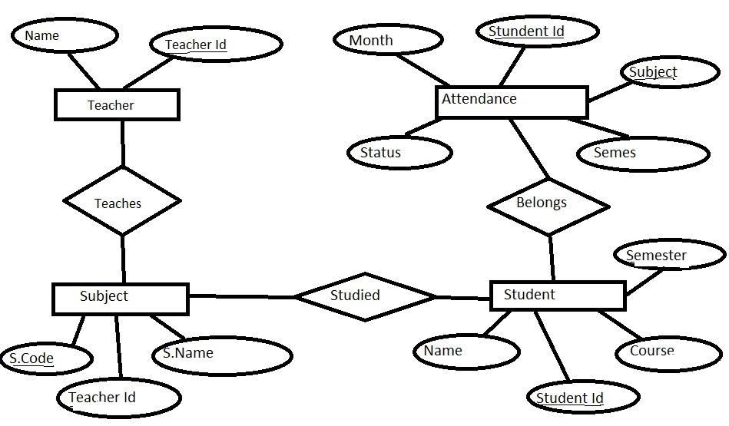

**Done By:-**

P.Jagadeesh(14052)

S.Nikhil (14064)

R.Tarun (13148)